**Kunal Sachdeva**

**4th Semester CSE NITRR**

**19115045**

**Switching Techniques in Data Communication**

**1.Abstract**

In large networks, there can be multiple paths from sender to receiver. The switching technique will decide the best route for data transmission. Switching technique is used to connect the systems for making one-to-one communication. There are variety of switching techniques used in Computer Networks. They were introduced as technologies progressed. When that technique found difficulties or wasn’t as effective, newer better techniques were formed based upon requirements. I have discussed about different switching techniques in data communication.

**2. Introduction**

Switching is process to forward packets coming in from one port to a port leading towards the destination. When data comes on a port it is called ingress, and when data leaves a port or goes out it is called egress. A communication system may include number of switches and nodes. At broad level, switching can be divided into two major categories:

* *Connectionless:* The data is forwarded on behalf of forwarding tables. No previous handshaking is required and acknowledgements are optional.
* *Connection Oriented:* Before switching data to be forwarded to destination, there is a need to pre-establish circuit along the path between both endpoints. Data is then forwarded on that circuit. After the transfer is completed, circuits can be kept for future use or can be turned down immediately.

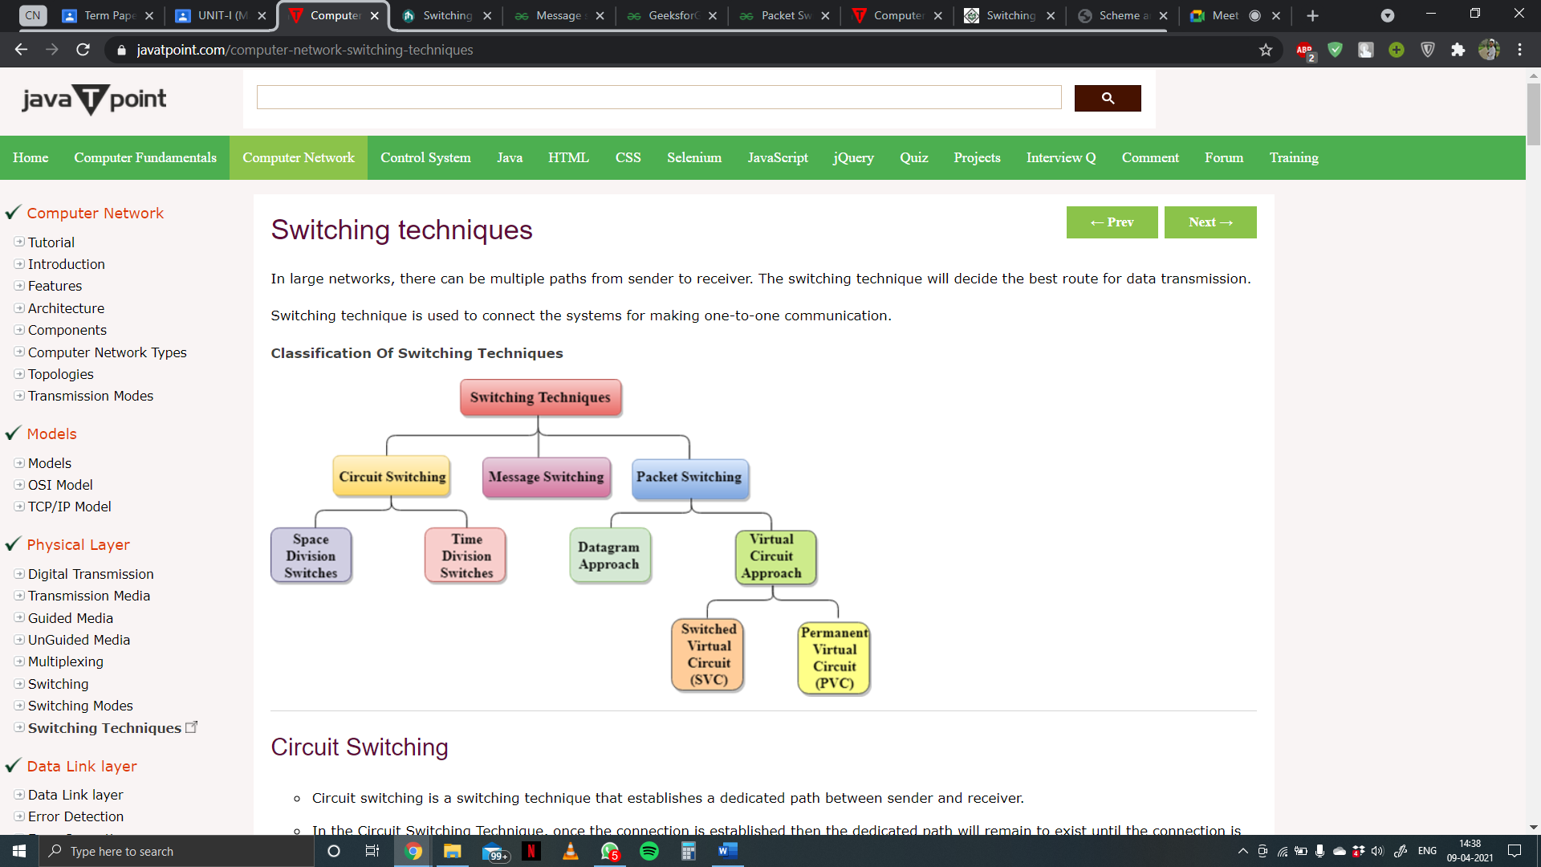Switched communication networks are those in which data transferred from source to destination is routed between various intermediate nodes. Switching is the technique by which nodes control or switch data to transmit it between specific points on a network.

Switching Techniques

There are 3 common switching techniques :-

1. Circuit Switching
2. Message Switching
3. Packet Switching

**3. Circuit Switching**

In circuit switching network resources (bandwidth) are divided into pieces and bit delay is constant during a connection. The dedicated path/circuit established between sender and receiver provides a guaranteed data rate. Data can be transmitted without any delays once the circuit is established. Telephone system network is one of the examples of Circuit switching.

* Circuit switching is a switching technique that establishes a dedicated path between sender and receiver.
* In the Circuit Switching Technique, once the connection is established then the dedicated path will remain to exist until the connection is terminated.
* Circuit switching in a network operates in a similar way as the telephone works.
* A complete end-to-end path must exist before the communication takes place.
* In case of circuit switching technique, when any user wants to send the data, voice, video, a request signal is sent to the receiver then the receiver sends back the acknowledgment to ensure the availability of the dedicated path. After receiving the acknowledgment, dedicated path transfers the data.
* Circuit switching is used in public telephone network. It is used for voice transmission.
* Fixed data can be transferred at a time in circuit switching technology.

*Communication through circuit switching has 3 phases :-*

1. Circuit establishment
2. Data transfer
3. Circuit Disconnect

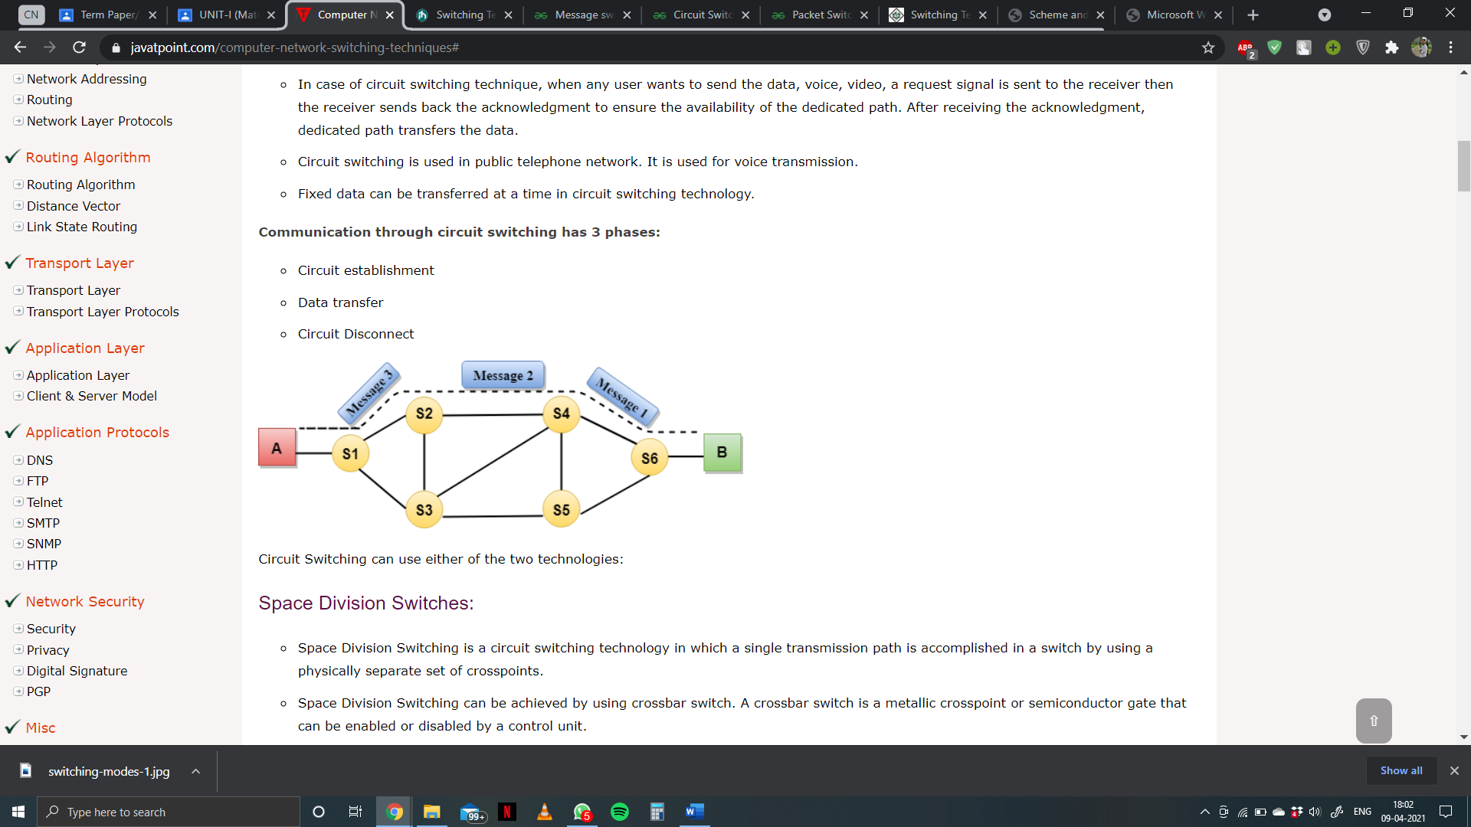

Circuit Switching

*Advantages of Circuit Switching :-*

It has the following advantages :

* The main advantage of circuit switching is that a committed transmission channel is established between the computers which give a guaranteed data rate.
* In-circuit switching, there is no delay in data flow because of the dedicated transmission path.

*Disadvantages of Circuit Switching :-*

It has the following disadvantages :

* Once the dedicated path is established, the only delay occurs in the speed of data transmission.
* It takes a long time to establish a connection approx. 10 seconds during which no data can be transmitted.
* It is more expensive than other switching techniques as a dedicated path is required for each connection.
* It is inefficient to use because once the path is established and no data is transferred, then the capacity of the path is wasted.
* In this case, the connection is dedicated therefore no other data can be transferred even if the channel is free.

**4. Message Switching**

* Message Switching is a switching technique in which a message is transferred as a complete unit and routed through intermediate nodes at which it is stored and forwarded.
* In Message Switching technique, there is no establishment of a dedicated path between the sender and receiver.
* The destination address is appended to the message. Message Switching provides a dynamic routing as the message is routed through the intermediate nodes based on the information available in the message.
* Message switches are programmed in such a way so that they can provide the most efficient routes.
* Each and every node stores the entire message and then forward it to the next node. This type of network is known as store and forward network.
* 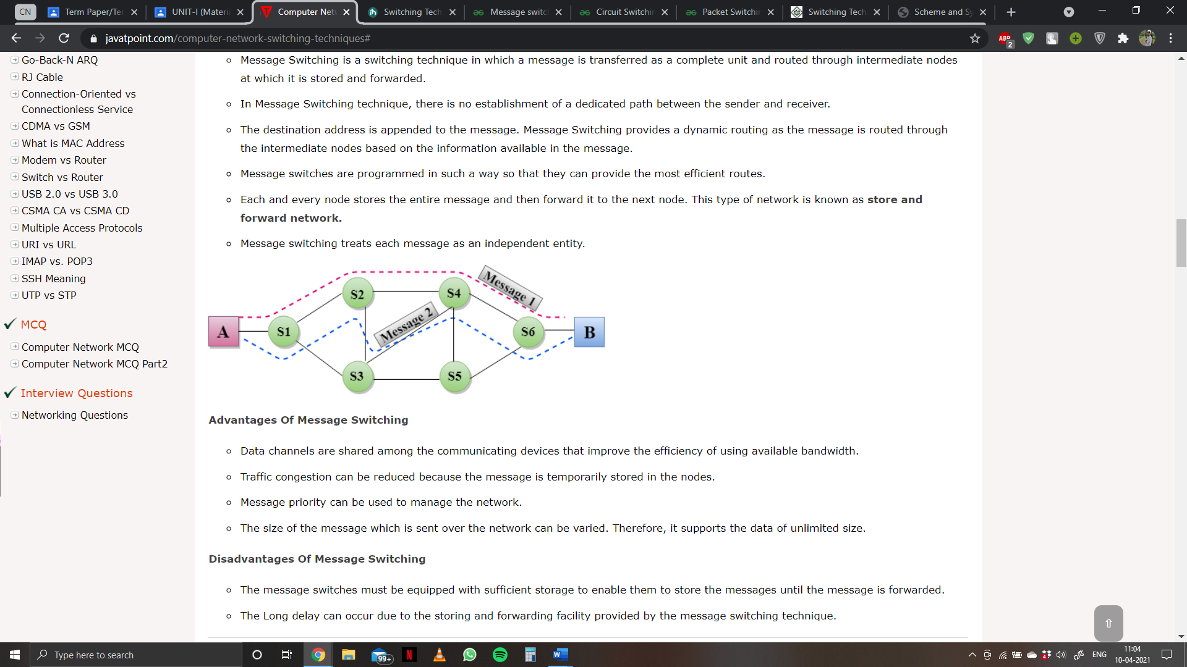Message switching treats each message as an independent entity.

Message Switching

*Characteristics of message switching :-*

Message switching is advantageous as it enables efficient usage of network resources. Also, because of the store-and-forward capability of intermediary nodes, traffic can be efficiently regulated and controlled. Message delivery as one unit, rather than in pieces, is another benefit.

However, message switching has certain disadvantages as well. Since messages are stored indefinitely at each intermediate node, switches require large storage capacity. Also, these are pretty slow. This is because at each node, first there us wait till the entire message is received, then it must be stored and transmitted after processing the next node and links to it depending on availability and channel traffic. Hence, message switching cannot be used for real time or interactive applications like video conference.

*Advantages of Message Switching :-*

It has the following advantages :

* Data channels are shared among the communicating devices that improve the efficiency of using available bandwidth.
* Traffic congestion can be reduced because the message is temporarily stored in the nodes.
* Message priority can be used to manage the network.
* The size of the message which is sent over the network can be varied. Therefore, it supports the data of unlimited size.

*Disadvantages of Message Switching :-*

It has the following disadvantages :

* The message switches must be equipped with sufficient storage to enable them to store the messages until the message is forwarded.
* The Long delay can occur due to the storing and forwarding facility provided by the message switching technique.

*Applications :-*

The store-and-forward method was implemented in telegraph message switching centres. Today, although many major networks and systems are packet-switched or circuit switched networks, their delivery processes can be based on message switching. For example, in most electronic mail systems the delivery process is based on message switching, while the network is in fact either circuit-switched or packet switched.

**5. Packet switching**

Packet switching is a method of transferring the data to a network in form of packets. In order to transfer the file fast and efficient manner over the network and minimize the transmission latency, the data is broken into small pieces of variable length, called Packet. At the destination, all these small-parts (packets) has to be reassembled, belonging to the same file. A packet composes of payload and various control information. No pre-setup or reservation of resources is needed.

Packet Switching uses Store and Forward technique while switching the packets; while forwarding the packet each hop first store that packet then forward. This technique is very beneficial because packets may get discarded at any hop due to some reason. More than one path is possible between a pair of source and destination. Each packet contains Source and destination address using which they independently travel through the network. In other words, packets belonging to the same file may or may not travel through the same path. If there is congestion at some path, packets are allowed to choose different path possible over existing network.

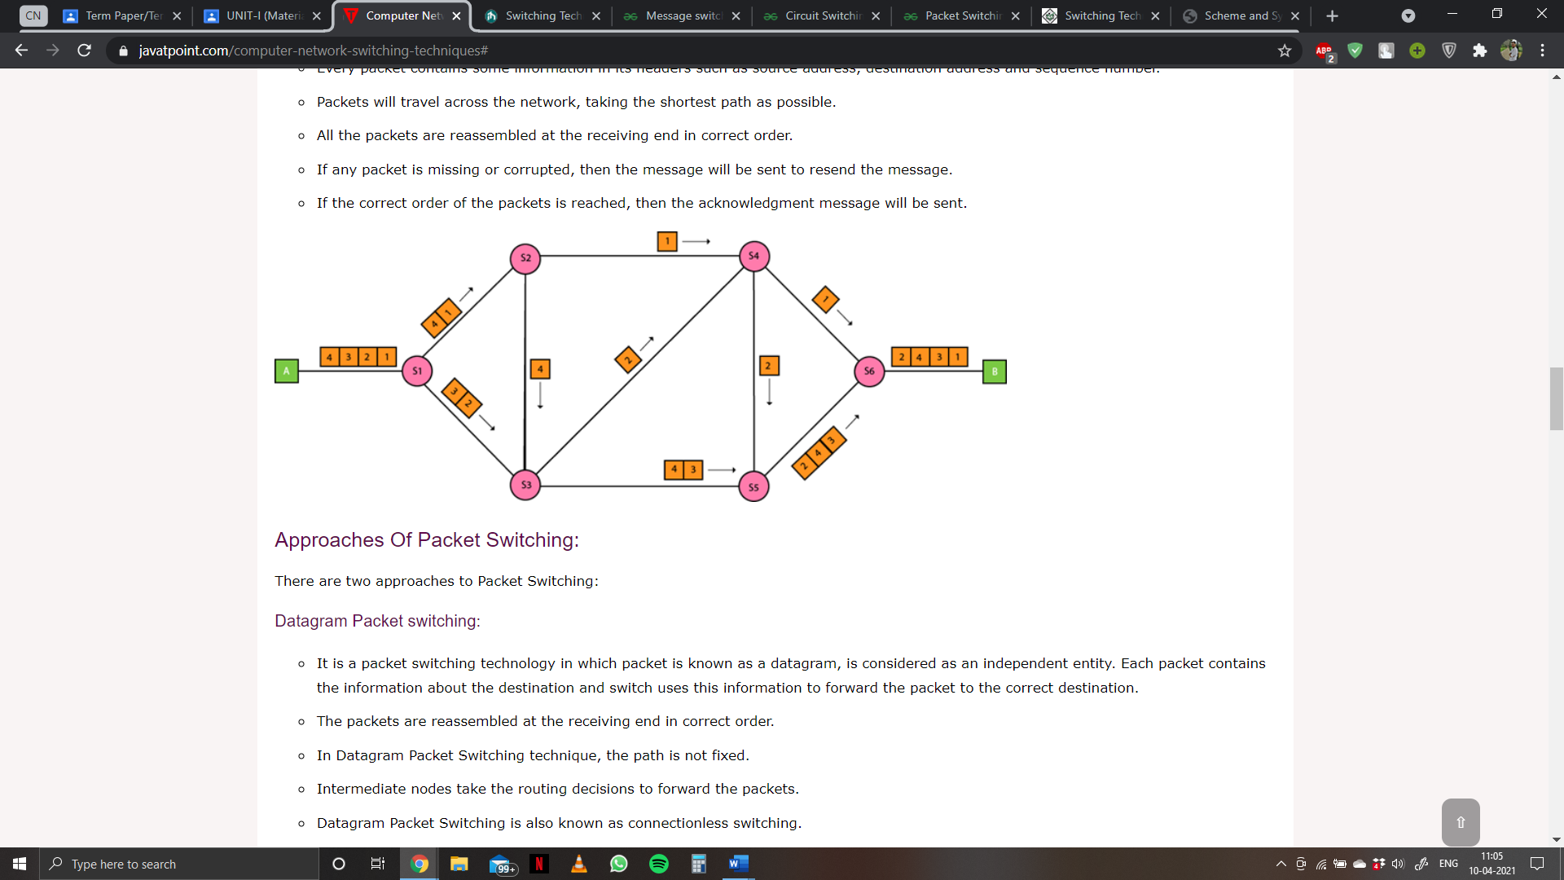

Packet Switching

* In packet switching message are broken up into packet.
* Each packet is tagged with appropriate source and destination address.
* Individual packets take different routes to reach the destination.

*Packet switching: Datagram*

* It is a packet switching technology in which packet is known as a datagram, is considered as an independent entity. Each packet contains the information about the destination and switch uses this information to forward the packet to the correct destination.
* The packets are reassembled at the receiving end in correct order.
* In Datagram Packet Switching technique, the path is not fixed.
* Intermediate nodes take the routing decisions to forward the packets.
* Datagram Packet Switching is also known as connectionless switching.

*Packet switching: Virtual*

* Virtual Circuit Switching is also known as connection-oriented switching.
* In the case of Virtual circuit switching, a preplanned route is established before the messages are sent.
* Call request and call accept packets are used to establish the connection between sender and receiver.
* In this case, the path is fixed for the duration of a logical connection.

To send a packet from A to B there are delays since this is a Store and Forward network.

*Delays in Packet switching :-*

* Transmission Delay
* Propagation Delay
* Queuing Delay
* Processing Delay

**6. Purpose of creating Packet Switching**

Packet-Switched networks were designed to overcome the weaknesses of Circuit-Switched networks since circuit-switched networks were not very effective for small messages.

*Advantage of Packet Switching over Circuit Switching :-*

* More efficient in terms of bandwidth, since the concept of reserving circuit is not there.
* Minimal transmission latency.
* More reliable as destination can detect the missing packet.
* More fault tolerant because packets may follow different path in case any link is down, Unlike Circuit Switching.
* Cost effective and comparatively cheaper to implement.

*Disadvantage of Packet Switching over Circuit Switching :-*

* Packet Switching don’t give packets in order, whereas Circuit Switching provides ordered delivery of packets because all the packets follow the same path.
* Since the packets are unordered, we need to provide sequence numbers to each packet.
* Complexity is more at each node because of the facility to follow multiple paths.
* Transmission delay is more because of rerouting.
* Packet Switching is beneficial only for small messages, but for bursty data (large messages) Circuit Switching is better.

*Differences between Circuit and Packet Switching :-*

|  |  |
| --- | --- |
| **Circuit Switching** | **Packet Switching** |
| In circuit switching there are 3 phases:  i) Connection Establishment.  ii) Data Transfer.  iii) Connection Released. | In Packet switching directly data transfer takes place . |
| In circuit switching, each data unit know the entire path address which is provided by the source. | In Packet switching, each data unit just know the final destination address intermediate path is decided by the routers. |
| In Circuit switching, data is processed at source system only | In Packet switching, data is processed at all intermediate node including source system. |
| Delay between data units in circuit switching is uniform. | Delay between data units in packet switching is not uniform. |
| Resource reservation is the feature of circuit switching because path is fixed for data transmission. | There is no resource reservation because bandwidth is shared among users. |
| Circuit switching is more reliable. | Packet switching is less reliable. |
| Wastage of resources are more in Circuit Switching | Less wastage of resources as compared to Circuit Switching |
| It is not a store and forward technique. | It is a store and forward technique. |
| Transmission of the data is done by the source. | Transmission of the data is done not only by the source, but also by the intermediate routers. |
| Congestion can occur during connection establishment time, there might be a case will be requesting for channel the channel is already occupied. | Congestion can occur during data transfer phase; large number of packets comes in no time. |
| Circuit switching is not convenient for handling bilateral traffic. | Packet switching is suitable for handling bilateral traffic. |
| In Circuit switching, charge depend on time and distance, not on traffic in the network. | In Packet switching, charge is based on the number of bytes and connection time. |
| Recording of packet is never possible in circuit switching. | While recording of packet is possible in packet switching. |

**References**

* <https://www.javatpoint.com/computer-network-switching-techniques#>
* <https://www.includehelp.com/computer-networks/switching-techniques-in-data-communication.aspx>
* <https://www.geeksforgeeks.org/message-switching-techniques/>
* <https://www.geeksforgeeks.org/circuit-switching-in-computer-network/>
* <https://www.geeksforgeeks.org/packet-switching-and-delays-in-computer-network/>
* <https://www.geeksforgeeks.org/difference-between-circuit-switching-and-packet-switching/>